**Git & Flask Assignment Submission Document**

### **✅ 1. Repository Setup & Initial Commit**

* Created a GitHub repository: **flask-todo-app**
* Cloned the repo to local directory: A:\DevOps\git\flask-todo-app
* Generated SSH key and added it to GitHub

Created and switched to a new branch:  
  
 git checkout -b kesarwanikhushi

* Added Flask project files:  
  + app.py
  + data.json
  + templates/index.html
  + static/style.css
  + requirements.txt
* Committed changes and pushed to GitHub
* Merged the kesarwanikhushi branch into main

**Screenshot Placeholder:**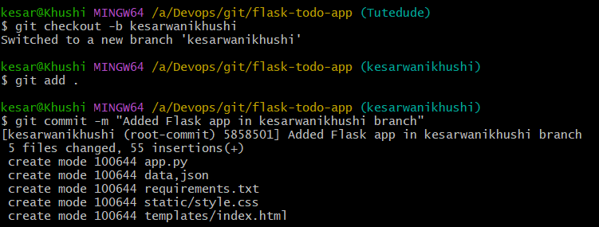

### **✅ 2. JSON File Update (Branch: kesarwanikhushi_new)**

Created new branch:  
  
 git checkout -b kesarwanikhushi_new

Edited data.json to update API content:  
  
 [

{ "title": "Build To-Do App", "status": "In Progress" },

{ "title": "Connect MongoDB", "status": "Done" }

]

* Committed and pushed changes
* Merged kesarwanikhushi_new into main
* Conflict resolved using changes from kesarwanikhushi_new

### **✅ 3. Feature Development & API Setup**

#### **Branch: master_1**

Created a new branch:  
  
 git checkout -b master_1

* Developed frontend To-Do form in templates/index.html:  
  + Fields: Item Name, Item Description
* Committed and pushed changes

#### **Branch: master_2**

Created a new branch:  
  
 git checkout -b master_2

* Added backend route /submittodoitem in app.py:  
  + Accepts POST request with itemName & itemDescription
  + Stores into MongoDB Atlas
* Committed and pushed changes
* Merged both branches into main

**Screenshot Placeholder:**

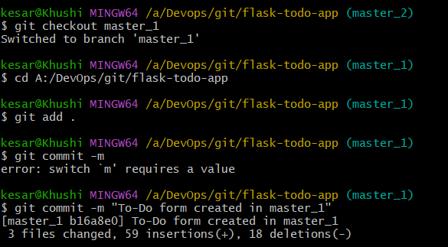

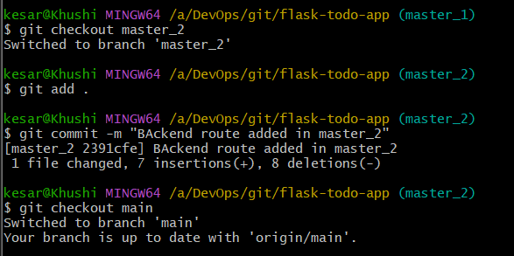

### **✅ 4. Enhancing To-Do Form with Commits (Branch: master_1)**

* Added new fields **one at a time** with commits:

**Item ID** field  
  
 git add .

git commit -m "Add Item ID field"

**Item UUID** field  
  
 git add .

git commit -m "Add Item UUID field"

**Item Hash** field  
  
 git add .

git commit -m "Add Item Hash field"

* Merged master_1 into main

### **✅ 5. Git Reset & Commit Deletion**

Used soft reset in main:  
  
 git reset --soft HEAD~2

git commit -m "Re-commit only Item ID field"

* Pushed updated state to remote

Rebasing back into master_1:  
 git checkout master_1

git rebase main

* Confirmed all commits are preserved (no squashing)

**Screenshot Placeholder:**

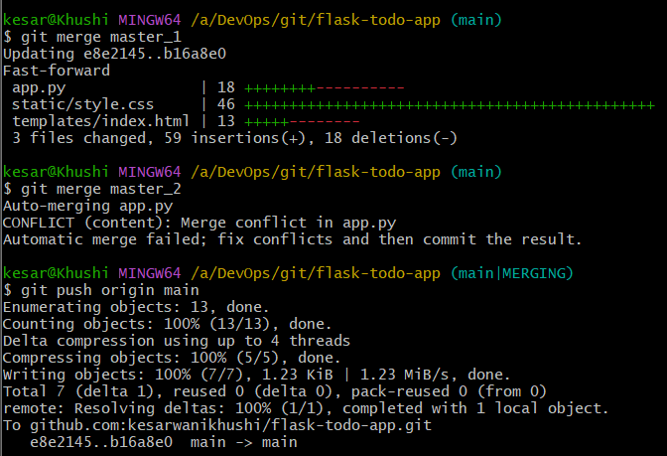

### **✅ Final Notes:**

* All branches properly pushed
* Conflicts (if any) resolved correctly
* MongoDB Atlas tested and connected
* /api route serves updated JSON data

**GitHub Repo Link:**

https://github.com/kesarwanikhushi/flask-todo-app